The Beautiful Black Bride Expo
Exhibitor Registration Form Please list as you would like information to appear on all publicity, marketing and advertisements.

Company/Business/Organization Information
Product or Service Provided ______________________________________________________________
Business Name_____________________________________________________________________________
Address______________________________________________________________________________
City_________________________________________________________State_______Zip___________
Phone__________________________________Contact Person____________________________________
Website Address_________________________________________________________________________
Email Address________________________________________________________________________
Company Tag line/Mission

Booth Set Up Requirements
Price per booth $299.00
Registration fee includes 1 table and 2 chairs. Please bring table cloths for your table. Please select additional items needed.
Check here if you need more chairs? $5 per how many __________________________________________________
All booth set up fabrics are black. All rented and used items must be returned in the condition that it was given.
50% Deposit due upon registration and is non-refundable.
Total $__________________ Todays Date_________ Final Payments are due by February 1, 2016

Payment Options
Please call Pinnacle Marketing Plus at 513-805-4146 to secure your spot today! Space is limited.
We accept the following, check one VISA MasterCard Discover American Express
Card #____________________________________Exp Date___________ CVV2___________Billing Zip_______________
Mail checks to 3137 Cypress Hill Drive Hamilton OH 45011, your spot is not secure until funds are received. Any returned checks will be charged a $25 service fee.

Event Details
The Beautiful Black Bride Expo
Saturday February 27, 2016 – 10 am– 6pm
By signing below and paying to participate in this event you are agreeing to all terms and conditions of this agreement.
Registration and participation in this event provides authorization to market and advertise the event approved logos on your company websites, etc. through December 31, 2016.
Your company representative must insure the booth area is ready and actively manned the entire length of the event.
You will have up to 1 hour before the event start time each day to complete setup and up to 1 hour after the event is has ended to complete breakdown. Please ensure all items in the booth area are completely removed with the exception of the tables, chairs, table cloths, and any additional rentals. You are responsible for any damaged or missing rental items. We will not be held responsible for any personal injuries or any lost or stolen items.
You will have access to the Vendor Hospitality Suite during the entire length of the expo. This will be a shared area by all of the vendor company representatives.
You must communicate the names of all the personnel that will be attending your booth at any point throughout all events. You will receive a vendor identification for all personnel and it must be worn at all times to grant access in and out of the events.
Your company booth, products, personnel and anything else out at the event will be subject to photographs and videos taken by event coordinators and used at the discretion of Pinnacle Marketing Plus.
You name and company information will not be sold under any circumstances.
“The Beautiful Black Bride Expo” is a trademark of Pinnacle Marketing Plus LLC. Please do not attempt to reproduce, recreate or market without approval.

Print Name __________________________________________________
Sign Name ___________________________________________________
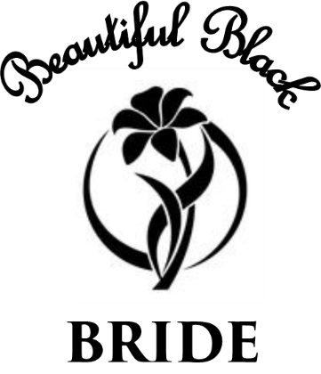
Date __________________________

